ANNEXURE A – CASE STUDY
Case Study 1: Shepherd Boy and Wolf
Problem:
A shepherd boy repeatedly cries “Wolf!” as a joke. The villagers come to help, but there is no wolf. Later, a real wolf appears, but the villagers ignore the boy's warning.
Assumption:
- Positive = Wolf is present
- Negative = Wolf is absent
- Prediction = Boy raises a “Wolf” alarm
Identification of TP, FP, FN and TN
Situation | Actual Condition | Prediction | Result
Boy cries “Wolf!” but no wolf is present | No Wolf | Wolf | False Positive (FP)
Real wolf appears but villagers ignore warning | Wolf | No Wolf | False Negative (FN)
Real wolf appears and warning is correctly accepted | Wolf | Wolf | True Positive (TP)
No wolf and no false alarm | No Wolf | No Wolf | True Negative (TN)
Conclusion:
The first false alarm represents FP, while the real wolf being missed represents FN. TP and TN are the correct prediction cases.

Case Study 2: Cat Image Classification
Problem Statement
A dataset contains 100 images, of which 30 contain cats and 70 do not contain cats. A machine learning model correctly identifies cats in 25 of the 30 cat images and correctly identifies the absence of cats in 50 of the 70 non-cat images.
Step 1: Confusion Matrix Values
True Positive (TP):
TP=25
False Negative (FN):
FN=30−25=5
True Negative (TN):
TN=50
False Positive (FP):
FP=70−50=20
Confusion Matrix
 | Actual Cat | Actual No Cat
Predicted Cat | TP = 25 | FP = 20
Predicted No Cat | FN = 5 | TN = 50
Step 2: Precision
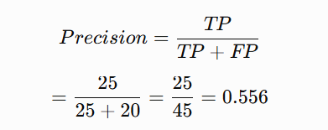

Step 3: Recall
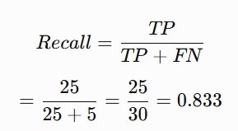

Recall = 83.33%
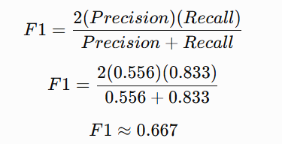
Step 4: F1 Score

F1 Score = 66.67%
Result
- TP = 25
- FP = 20
- FN = 5
- TN = 50
- Precision = 55.56%
- Recall = 83.33%
- F1 Score = 66.67%
Conclusion:
The model has a high recall of 83.33%, meaning it identifies most cat images correctly, but its precision is lower because it incorrectly predicts some non-cat images as cats.

Case Study 3: Spam Email Classification Using Naïve Bayes
Problem Statement
An email service provider wants to classify emails as Spam or Not Spam using the following features:
- Contains “Offer” – Yes/No
- Contains “Free” – Yes/No
- Email Length – Short/Long
Given Dataset
Offer | Free | Length | Class
Yes | Yes | Short | Spam
Yes | No | Long | Not Spam
No | Yes | Short | Spam
No | No | Long | Not Spam
Yes | Yes | Long | Spam
No | No | Short | Not Spam
Total emails = 6
Spam emails = 3
Not Spam emails = 3
1. Prior Probabilities
Probability of Spam
P(Spam)=63​=0.5
Probability of Not Spam
P(NotSpam)=63​=0.5
Therefore:
P(Spam) = 0.5
P(Not Spam) = 0.5

2. Conditional Probabilities
For Spam
There are 3 Spam emails.
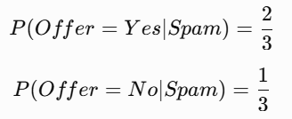
Offer

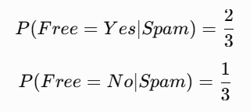
Free

Length
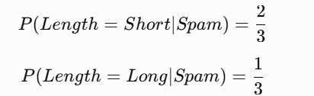

For Not Spam
Offer
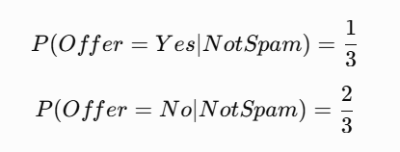

Free
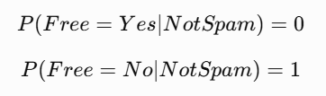

Length
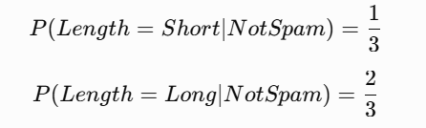

Conditional Probability Table
Feature | Spam | Not Spam
Offer = Yes | 2/3 | 1/3
Offer = No | 1/3 | 2/3
Free = Yes | 2/3 | 0
Free = No | 1/3 | 1
Length = Short | 2/3 | 1/3
Length = Long | 1/3 | 2/3

Classify the New Email Using Naïve Bayes
New Email
Offer = Yes, Free = No, Length = Short
For Spam
P(Spam∣X)∝P(Spam)×P(Yes∣Spam)×P(No∣Spam)×P(Short∣Spam)
=0.5×32​×31​×32​
=0.0741
For Not Spam
P(NotSpam∣X)∝P(NotSpam)×P(Yes∣NotSpam)×P(No∣NotSpam)×P(Short∣NotSpam)
=0.5×31​×1×31​
=0.0556
Since:
0.0741>0.0556
Final Classification: SPAM

4. Comparison Using WEKA
The same dataset can be tested using WEKA Naïve Bayes classifier.
Procedure
- Open WEKA Explorer.
- Select Preprocess.
- Load the email dataset.
- Select Classify.
- Click Choose.
- Select Bayes → NaiveBayes.
- Select Cross-validation.
- Click Start.
- Observe the classification results and confusion matrix.
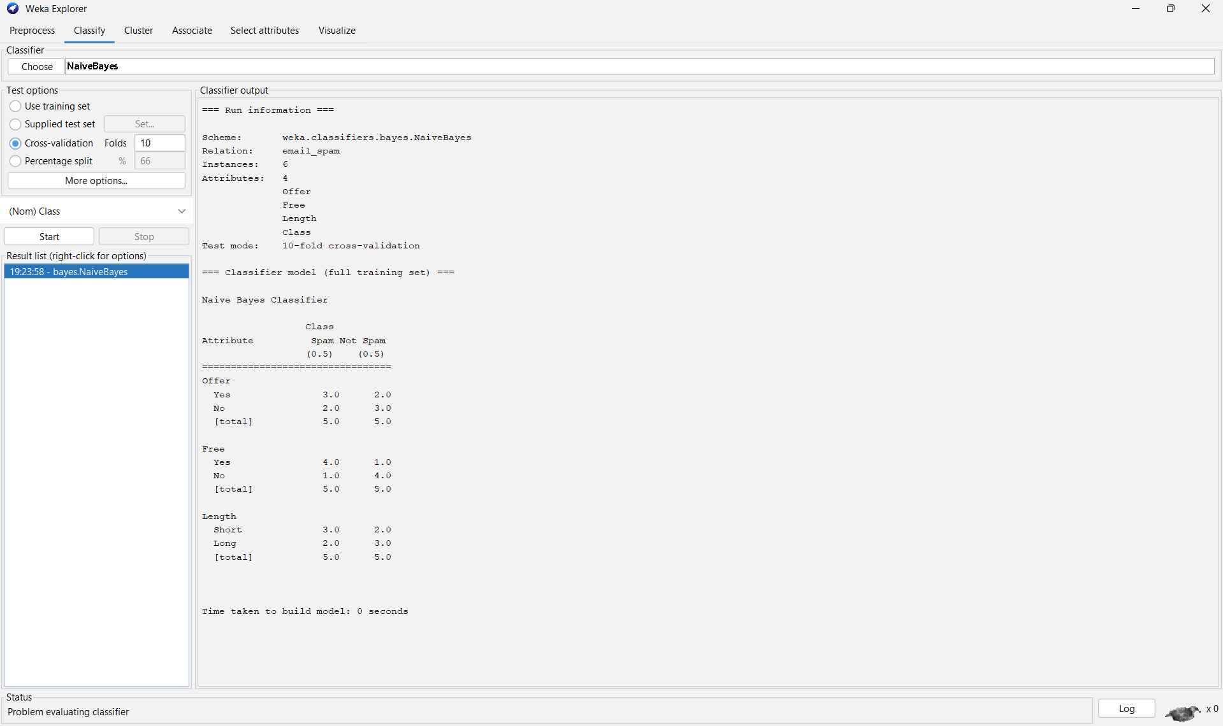

Comparison
Method | Classification
Manual Naïve Bayes | Spam
WEKA Naïve Bayes | Spam
Result:
The manual Naïve Bayes calculation and WEKA classifier give the same classification for the given email.
5. Independence Assumption in Naïve Bayes
Naïve Bayes assumes that the input features are independent of each other when the class is known.
For this case, it assumes that:
- “Offer”
- “Free”
- “Length”
are conditionally independent for Spam or Not Spam emails.
Therefore:
P(Offer,Free,Length∣Spam)
is calculated as:
P(Offer∣Spam)×P(Free∣Spam)×P(Length∣Spam)
Discussion
- The assumption makes the algorithm simple and fast.
- In real-world emails, features may be related.
- For example, “Offer” and “Free” may frequently occur together.
- Therefore, complete independence may not always be true.
- However, Naïve Bayes can still provide good results for spam email classification.
Overall Conclusion
These case studies demonstrate how confusion matrices, Precision, Recall, F1 Score, and Naïve Bayes classification can be used to evaluate and classify machine learning predictions. The cat classification case demonstrates performance metrics, while the spam email case demonstrates how Naïve Bayes calculates probabilities and performs classification.

